SIR SYED UNIVERSITY OF ENGINEERING & TECHNOLOGY
COMPUTER SCIENCE & INFORMATION TECHNOLOGY DEPARTMENT

Spring 2024
Software Engineering (CS-226)
Assignment # 3

Semester: 4th Batch: 2022F
Student’s Name: Muhammad Faisal Roll#:2022F-BCS-152 Section: C
Total Marks: 4 Marks Obtained:
CLO # | Course Learning Outcomes (CLOs) | PLO Mapping | Bloom’s Taxonomy
CLO 3 | Apply the software engineering knowledge to suggest an appropriate solution that meets the customer’s requirements. | PLO_3  (Academic Education) | C3  (Applying)

Instructions:
1. Use of Generative AI is not allowed.
2. Any answer that is more than 40% identical to another assignment’s answer will get 0 marks.

Q1. Describe the following diagram. State which type of testing is being done, the details of the components and description of process.

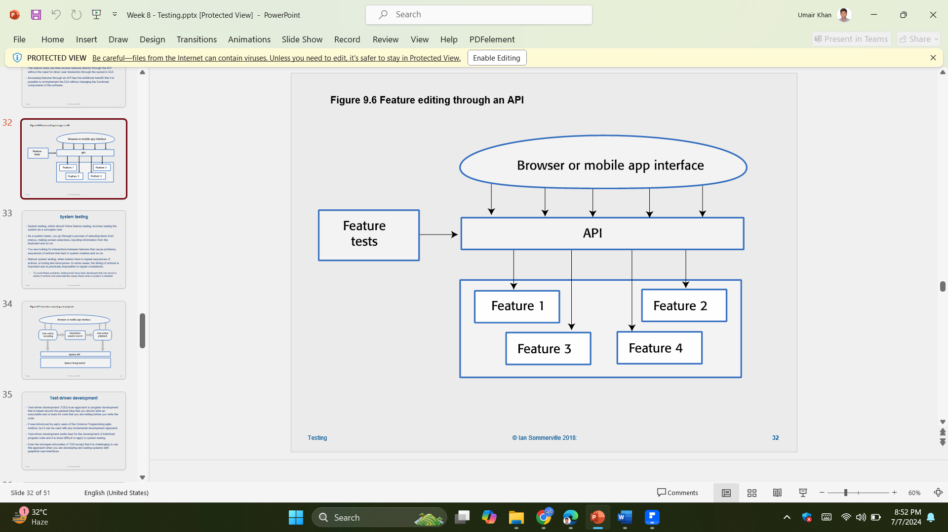

The diagram describes a high-level architecture of the software application that focuses on the integration of feature testing. Here’s a detailed breakdown:

Components and Description

- Browser or Mobile App Interface
This is the User Interface through which the user interacts with the application. It could represent either a web browser or even a mobile application.

- API (Application Programming Interface)
It acts as an intermediary layer between the UI and the exposed backend features, opening endpoints callable by the UI for various operations.

- Feature 1, Feature 2, Feature 3, Feature 4
These are individual features or services of the application. Each feature will wrap certain functionality and can be developed and tested in isolation.

- Feature Tests
These are automated tests that are intended to check the functionality of each single feature. The features confirm that all of them work according to their specifications.

Process Description

- User Interaction
The interaction of the users with the application takes place through the interface developed for browsers or a mobile application. Their activities lead to making API calls to handle certain activities.

- API Requests
The API receives requests from the UI. These are consequently channeled to the applicable features of the backend with respect to functionality being accessed.

- Feature Execution
The API processes the requests and dispatches them to respective appropriate features (Feature 1, Feature 2, Feature 3, Feature 4). Based on the function ordained for each feature, every feature performs its operation and sends back the results to the API.

- Response Handling
The results are then picked up by the API from the features, who sends the appropriate responses back to the UI for display to the user.

- Feature Testing
The purpose of the feature tests is to verify the functionality of every feature in the program. These tests mimic events to ensure that the features work correctly under all circumstances. The results from these tests facilitate the detection of any issues or bugs in the features.

Type of Testing

The testing being illustrated by the diagram is Feature Testing. It involves:
- Isolating each feature to ensure that it works correctly.
- Verify that each feature meets its requirements
- Automate Tests to efficiently and repeatedly verify features are working

What this diagram is trying to tie together is an application architecture in which the UI interacts with the back-end features via API, while testing ensures the correctness of each feature.

